- February 2019 variant3 Task1 examination:
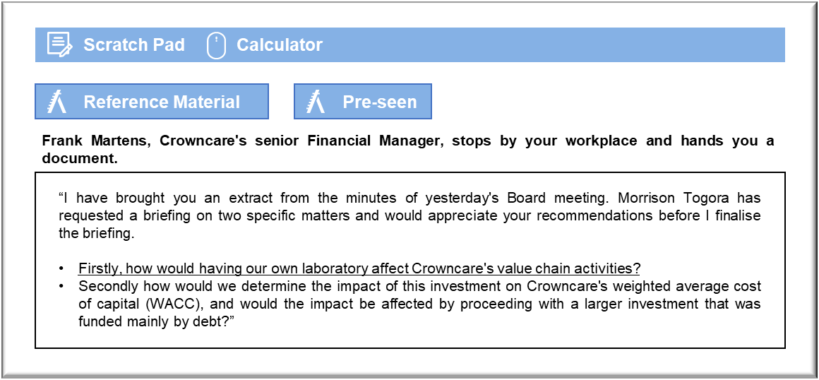

Value chain activities

Creating an in-house laboratory makes Crowncare directly responsible for inbound logistics, operations and outbound logistics relating to laboratory services. At present, the responsibility for managing inventories of materials, manufacturing quality and delivery lies with the laboratories whom we trade with. Crowncare would be directly responsible for each of those areas if it established its own laboratory. Equally, our own laboratory would give us control, which could be advantageous in terms of managing priorities.

Having a laboratory could support marketing and sales activities by demonstrating a commitment to detail and to excellence by Crowncare. The fact that we would no longer have to pay the margin charged by an independent laboratory could create opportunities to reduce prices, or simply to promote discretionary treatments that require laboratory work more forcefully.

The laboratory would offer little change in the way of after sales service. Defective items are likely to require replacement rather than adjustment and so having an inhouse laboratory would not enable, say a chipped crown to be repaired. Perhaps the greater control would enable Crowncare to rectify any problems by prioritising the creation of a defective bridge or crown. Support activities would also be affected.

Crowncare would have far greater control over the technology development activity. If, say, a new manufacturing process becomes available then Crowncare’s Board can decide to acquire it and use it heavily across the Group. Independent laboratories might be reluctant to invest because they cannot necessarily guarantee that they will sell the output and so their customers cannot necessarily have access to the resulting benefits.

Crowncare will face fresh challenges in human resource management because the recruitment and retention of skilled staff will become the Group’s direct responsibility. If an independent laboratory loses a key technician then Crowncare can simply shift to an alternative laboratory, but that is more difficult to justify when there is an in-house facility.

The in-house laboratory would have little impact on procurement or broader issues of firm finance. Those activities will be relatively unaffected because Crowncare will undoubtedly have supervisory and administrative staff to take care of them. The size of the laboratory may dictate whether certain issues are cost-effective. For example, a larger laboratory can take advantage of its size in the procurement process, seeking discounts and so on.

WACC

Crowncare is presently funded entirely by equity, so the WACC is the same as the cost of equity. That is essentially the rate of return expected by the shareholders for taking the risk of investing in a particular company’s shares. The dividend valuation model might be used, firstly by looking at historical dividends and dividend growth and secondly by looking at shareholder expectations arising from the change brought about by the acquisition of a dental laboratory. If the shareholders believe that their investment has become more risky then the value of the equity will fall and the cost of equity will increase.

Crowncare is unquoted and so the share price cannot be observed. The cost of equity may be estimated by looking for quoted dental companies and using market prices to estimate their cost of equity. The impact of the investment could be estimated by looking for a quoted dental company because the overall cost of equity could then be estimated as a weighted average of the two costs of equity. It may be necessary to search for quoted companies that are in broadly similar lines of business, such as medical care, because it is unlikely that there will be a direct comparison. Crowncare is presently funded by equity. Borrowing heavily to acquire a large laboratory will reduce the weighting attached to equity from 100% to a lower amount Debt is generally cheaper than equity, so borrowing heavily to expand the company would reduce the WACC. Borrowing will, however, increase the risk to shareholders because Crowncare will have to service the loan from profits and cash flows. Increasing risk also increases the cost of equity and that will offset the savings to some degree. The overall effect will require significant estimates and assumptions and so there can be no real certainty about the net effect on WACC.

Borrowing will also reduce WACC because loan interest is an expense for tax purposes. Dividends paid to shareholders attracts no tax relief and so borrowing further reduces WACC because of the tax saving.

